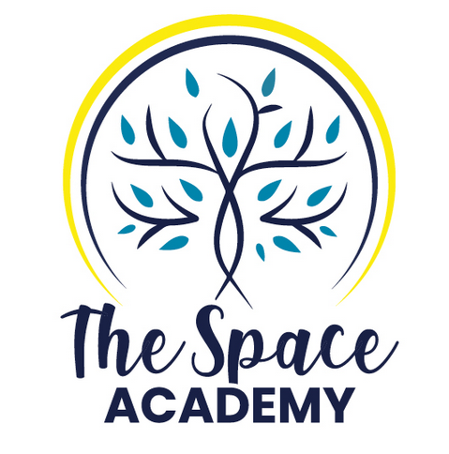
Application Form

Full name:
Email: Telephone number:
Address:
Age: Nationality:
Work :
Emergency contact number:

Do you have any health conditions?

How long have you been practicing Yoga? How many times a week, and which style(s)?

Do you have a home practice?

Describe your pranayama experience.

Describe your meditation experience.

Have you already participated in a Yoga teacher training course? If so, which one(s)?

Do you currently teach Yoga? If so, in which studio(s)?

Why have you chosen to train with The Space Academy?

What are your expectations for this training?

Is there anything else you wish to share?

Please note that be completing this form and applying for your training course, you agree to our refund and cancellation policy.
The deposit required to reserve your spot is non-refundable.
In case of cancellation more than 3 months before the start of the course, all fees will be refunded, minus the non-refundable deposit.
In case of cancellation between 3 and 1 month* before the start of the training, a 50% refund will be issued, minus the non-refundable deposit.
In case of cancellation under 1 month before the start of the course, no refund will be issued, and full payment of any remaining amount is considered due.
For full details of the amount of your deposit, please consult the training page of our website (the course you are applying for), as the amount does depend on the course.
*between 3 and 2 months for the 300h training
**less than 2 months for the 300h training

